**DBO/CEO/AMBON Cruise Report for Norseman II**

**Oct 2-22, 2020, Nome-Nome**

**Chief Scientist:** Jackie Grebmeier, Chesapeake Biological Laboratory, University of Maryland Center for Environmental Science (UMCES) ([jgrebmei@umces.edu)](mailto:jgrebmei@umces.edu))

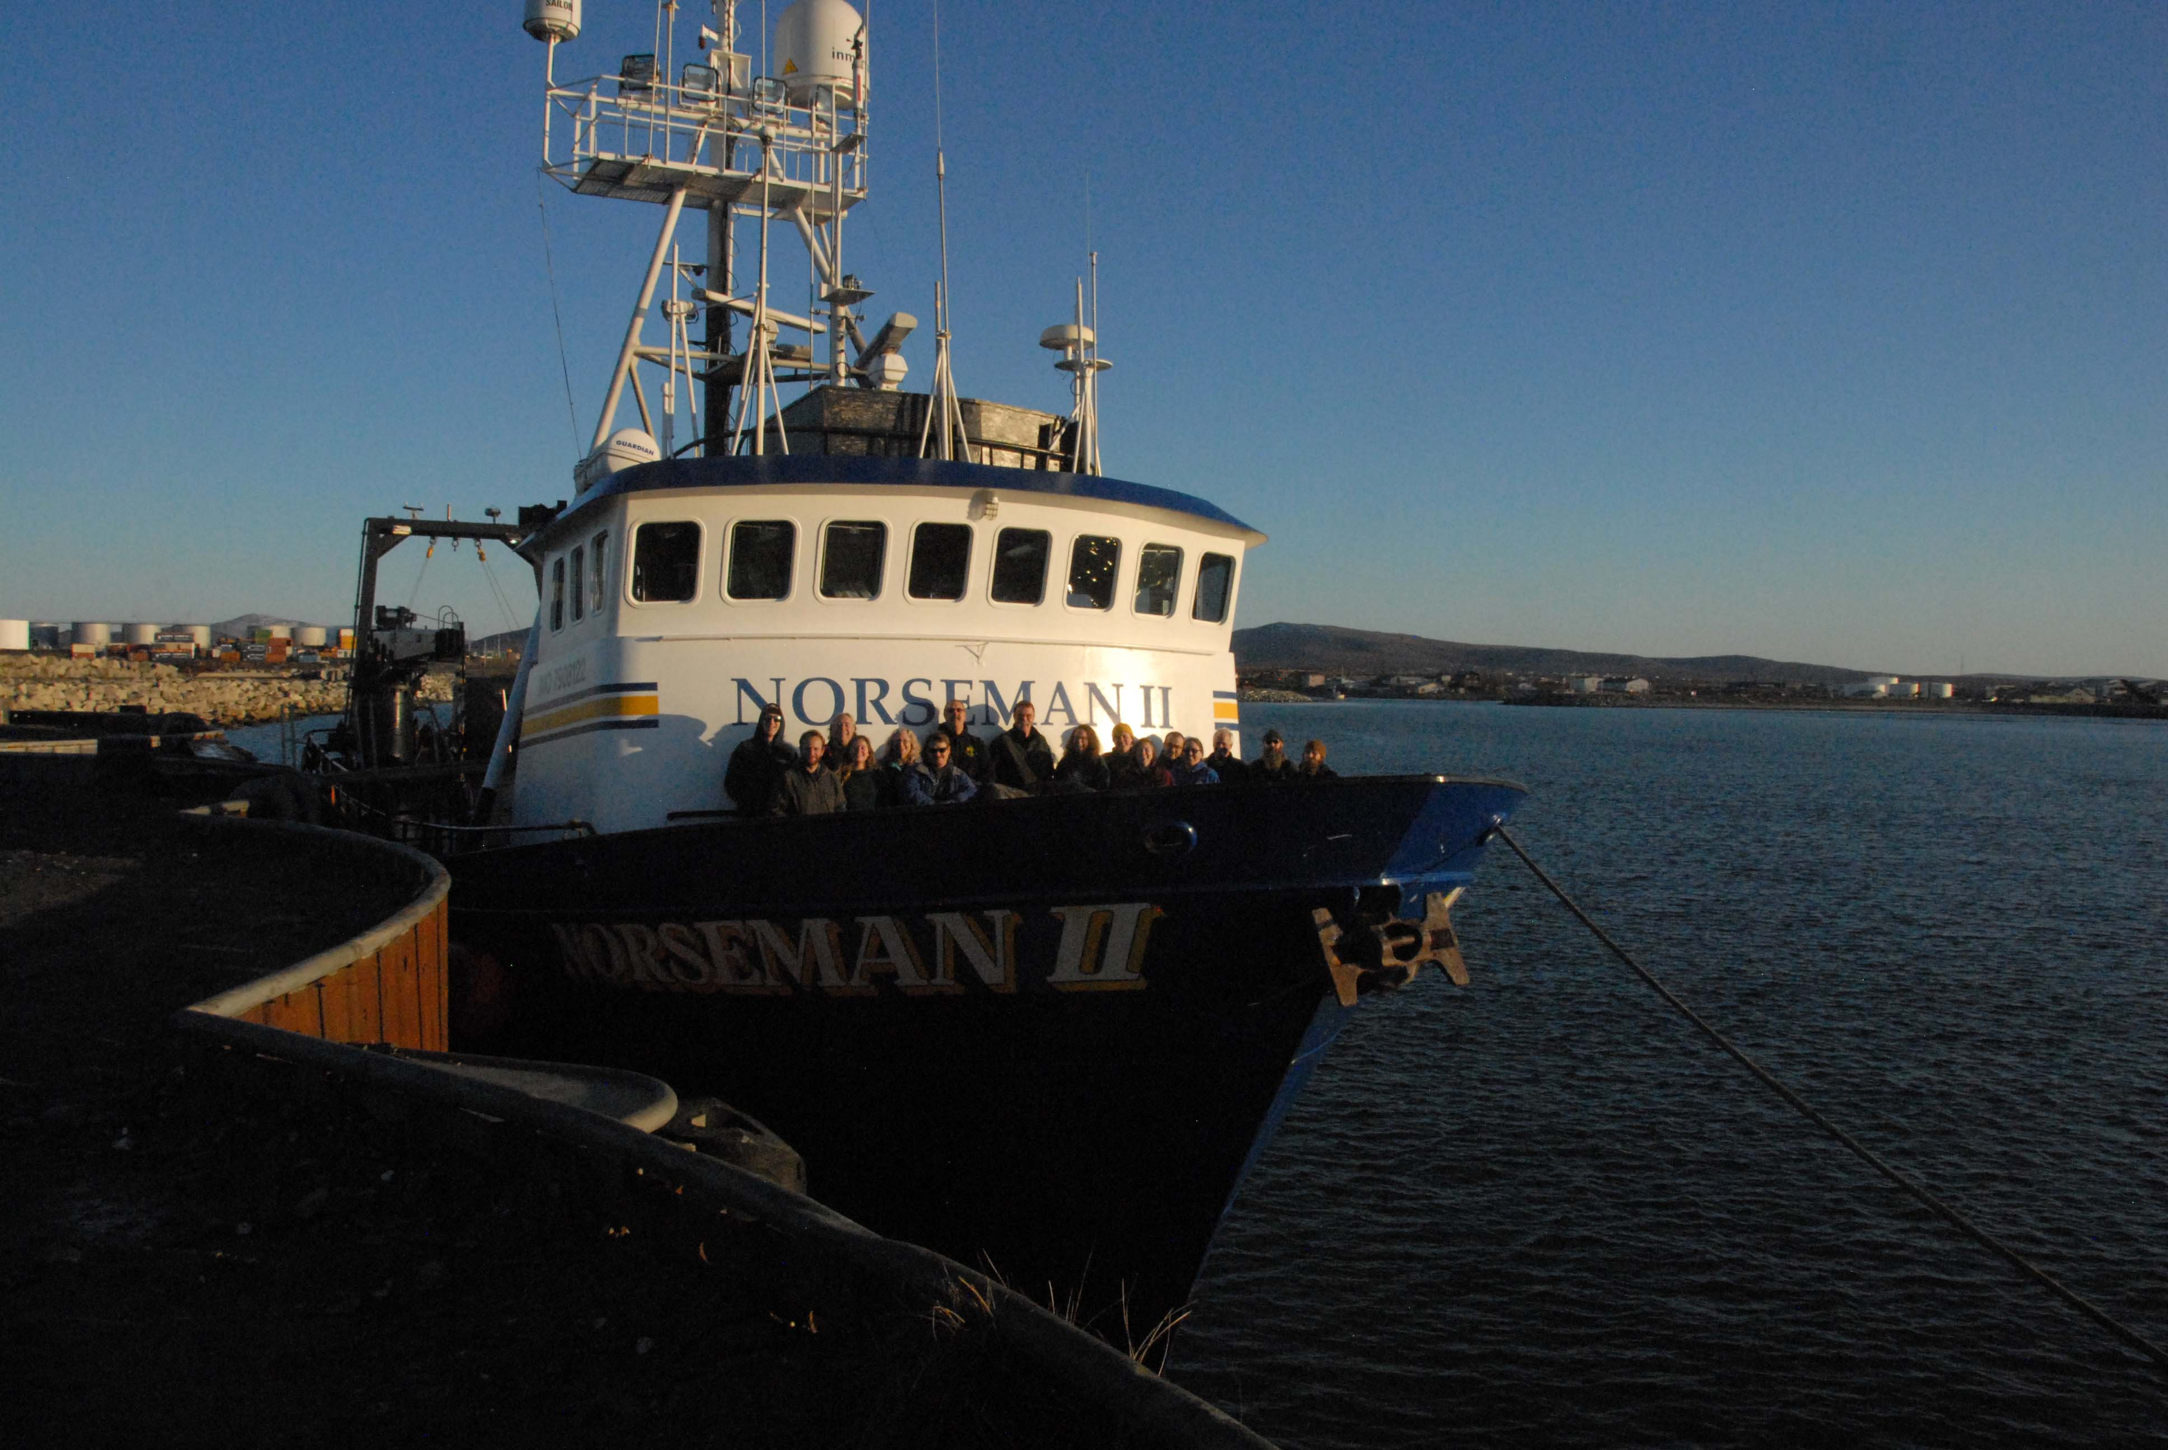

**Overview:** The goal of the fall DBO cruise on the Norseman II was toevaluate ecosystem status and change at the Distributed Biological Observatory (DBO) time series sites, to deploy a mooring and sediment trap at the M8 site in the northern Bering Sea (DBO1 region), and to turn around the Chukchi Ecosystem Observatory (CEO) mooring array in the NE Chukchi Sea (DBO4 region). The DBO fall cruise was a consortium of funded projects from the National Oceanic and Atmospheric Administration (NOAA), the North Pacific Research Board (NPRB), National Ocean Partnership Program (NOPP), Arctic Marine Biodiversity Observing Network (AMBON), and Alaska Ocean Observing System (AOOS), focused on benthic sampling as well as water column measurements. The cruise departed from Nome, Alaska with a limited scientific team participating for the planned water column and sediment sampling on the five DBO transect lines in the northern Bering and Chukchi Seas and mooring turnaround. A new sediment trap was deployed at the M8 site that is a collaborative project between Jackie Grebmeier (UMCES) and Phyllis Stabeno and Calvin Mordy (NOAA/EcoFOCI) through a NPRB funded project led by Catherine Lalande (Université Laval). In addition, we deployed a M8 mooring for Phyllis Stabeno (NOAA EcoFOCI). The cruise also turned around a mooring/sediment trap array at the Chukchi Ecosystem Observatory (CEO) in the NE Chukchi Sea that led by Seth Danielsen (University of Alaska Fairbanks (UAF)/NPRB/AOOS). Collaboration occurred through AMBON supported eDNA collections with Matt Galaska (UW/NOAA) as well as cross-data evaluation through the NOAA Arctic Research Program water column and benthic DBO data collections, and the Alaska Harmful Algal Bloom (HAB) network for sediment and dominant macrofaunal studies. The scientific team included personnel from: UMCES (4) and UAF (4), totaling 8 scientists (maximum due to berthing limitations associated with for COVID-19 safety protocol negotiated by Service Vessels of Alaska, the vessel owner) following a required quarantine in Anchorage prior to a charter flight to Nome, Alaska to fully isolate the scientific team from possible viral infection sources.

1. **Schedule:**

* The science team quarantined for 7 days in Anchorage (after a travel day), with COVID-19 testing prior to departure to Alaska, then on the 4th day in Anchorage. Once negative results were confirmed the science party departed on a charter flight from Anchorage to Nome, with immediate transport from the tarmac in Nome directly to the ship.
* Norseman II schedule
  + 10/1/20, NS2 arrives to Nome, loaded science cargo in storage via Lynden Freight
  + 10/2/20-scientists fly from Anchorage by charter plane, board the ship, it departs
  + 10/22/20-NS2 returns to Nome, AK
  + 10/23/20-scientists embark and fly home

1. **Science participants/projects (n=9)** include:
2. Jacqueline Grebmeier, UMCES; Chief Scientist; [jgrebmei@umces.edu](mailto:jgrebmei@umces.edu)
3. Lee Cooper, UMCES; Co-PI; [cooper@umces.edu](mailto:cooper@umces.edu)
4. Christina Goethel, UMCES, PhD student; [cgoethel@umces.edu](mailto:cgoethel@umces.edu)
5. Clare Gaffey, University of Alaska Fairbanks (UAF), PhD student; [cgaffey@clarku.edu](mailto:cgaffey@clarku.edu)
6. Ruth Cooper, CBL/UMCES, MD, volunteer; [Rcooper@nas.edu](mailto:Rcooper@nas.edu)
7. Peter Shipton, UAF; [pshipton@alaska.edu](mailto:pshipton@alaska.edu)
8. Jordi Maisch, UAF; [jcmaisch@alaska.edu](mailto:jcmaisch@alaska.edu)
9. Savannah Sandy, UAF; [ssandy3@alaska.edu](mailto:ssandy3@alaska.edu)

**C. The DBO, AMBON, CEO and EcoFOCI science activities included** two mooring deployments with sediment traps and core water column and sediment sampling on the 5 DBO sampling lines in the northern Bering and Chukchi Seas (**Figure 1).** **Table 1** provides a station list, dates, and activities for the cruise.

The shipboard sampling included CTD/rosette sampling for temperature, salinity, and vertical water column sampling for other water column indicators. The CTD was deployed at all DBO stations and the two mooring sites (M8 in DBO1 region and CEO in the DBO4 region). We will collect water for chlorophyll, phytoplankton taxonomy, nutrients, oxygen-18/16 ratios, eDNA, zooplankton, van Veen grab deployments for macrofauna (population studies) and sediments (carbon content, grain size, HABS), and a single HAPS core deployment for collection of undisturbed sediment cores for carbon cycling experiments at select stations. A seabird observer on the bridge will complete the core DBO standard activities.

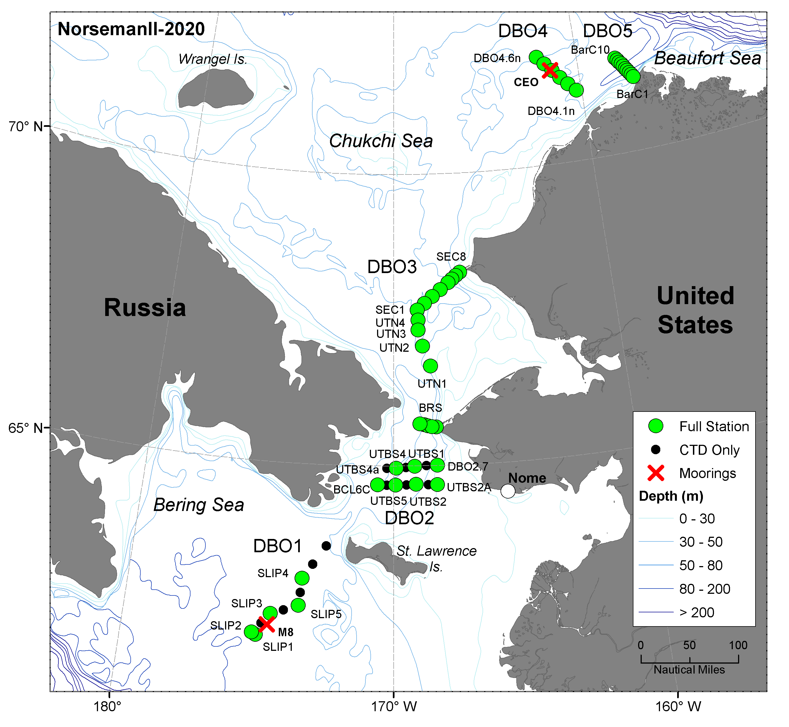

**Figure 1**. Fall DBO Arctic cruise sampling on the Norseman II.

**Activities and Order of Sampling**

* Moorings: Peter Shipton
* CTD deployments: Jordi Maisch and Peter Shipton
* Water column: chlorophyll, nutrients, O-18, phytoplankton IDs-Lee Cooper, Christina Goethel, Ruth cooper
* Water column: eDNA-Clare Gaffey
* Zooplankton: Savannah Sandy
* Sediments and macrofauna: Jackie Grebmeier, Christina Goethel, Ruth Cooper

**Table 1. List of stations occupied during NS2020.**



**D. Individual Cruise Reports**

**D1. CEO Mooring Report: 2019-2020 (Peter Shipton/Jordi Maisch/Seth Danielson)**

**D1.1 CEO-19**

**a. CTD cast #001(CEO_19_cal cast_2020_10_05**) was deployed at **21:58 UTC on October 5th at 71°35.909’ N, 161° 30.872’ W**. The cast went to about 41 meters. At 33 meters water was taken to sample nutrient, chlorophyll and pCO2 for calibration purposes.

**b. The** **CEO2-19** mooring was deployed off of the Ocean Starr at **71° 35.9796’N, 161° 31.6478’ W on August 19th, 2020 at 16:03 UTC.** On **October 5th, 2020 at 23:12** UTC a release command was sent to the mooring and it surfaced. The mooring was recovered with 3 picks from the Norseman II’s stern A-frame with care taken to not tip the sediment trap. This mooring had a Viny float frame instrument package at 33 meters below the surface and a HydroBios Sediment trap at 37 meters below the surface. The viny frame contained an Acoustic Zooplankton Fish Profiler (AZFP), a Satlantic Submersible Underwater Nitrate Analyzer (SUNA), a Seabird SBE- 16plus with a PAR, Triplet, and an SBE43, a Kongsberg HydroC(pCO2), and a Sequoia Scientific LISST(particle camera). The AZFP contains 4 different frequency transducers (38 kHz, 125 kHz, 200 kHz, and 455 kHz) and was sampling every 20 seconds. The SUNA optically measures nitrate every hour. The SBE 16plus took Temperature, Conductivity, Pressure, CDOM, Transmissivity, Chlorophyll, solar irradiance, and oxygen measurements every 2 hours. The HydroC measures PCO2 and took measurements every 12 hours. The LISST took images once an hour.

The sediment trap collected 24 separate samples that varied in the span of time collected from 7 days to 31 days. The timing of these intervals was designed to capture the spring bloom (7 day intervals) in discrete bottles, while the winter months were set to longer intervals (31 days) due to the reduced sedimentation rate at those times.

**D1.2 CEO1-19** mooring was deployed off of the Ocean Starr at **71° 35.9712’N, 161° 30.4193’ W on August 19th, 2020 at 16:18 UTC.** The CEO1-19 mooring was sent a release command at **23:47 UTC** on **October 5th, 2020**. The mooring was then recovered in 2 picks off of the Norseman II’s stern A-frame at **23:58**. This mooring contained an Acoustic Doppler Current Profiler (ADCP) with a wave measuring function at 33 meters below the surface. This instrument took current measurements every 20 minutes and wave measurements once an hour. The mooring also had 2 CTDs sampling every 15 minutes; one at 33 meters and one at 43 meters below the surface. A SoundTrap (passive acoustic recorder) was mounted 35 meters below the surface to record marine mammal sounds.

**D1.3** The **CEO2-20** mooring was deployed at **71° 35.9947’ N, 161° 31.5553’ W on October 7th at 00:49 UTC.** This mooring was deployed anchor first with 2 quick releases using the ship’s crane to lift the instruments and an A-frame winch to pick up the releases and train wheel. The A-frame then lowered the train wheel into the water until the weight was fully transferred to the crane. The A-frame winch’s quick release was then triggered. Next the crane lowered the mooring into the water until the top viny frame was in the water and its quick release was triggered; deploying the mooring.

The CEO2-20 has some reduced sampling rates from previous years to allow for 2 years of sampling in the event that a 2021 CEO cruise will not occur. This year the AZFP**(33m)** will be sampling every 60 seconds. The SUNA**(33m)** will run once an hour, with an external battery pack that will allow for 750 days of data collection. The Seabird SBE37SMP-ODO**(33m)** (CTD with oxygen) will run every 2 hours, as will the stand alone optical sensors (ECO-PAR**(33m)** (irradiance)) and ECO-triplet **(33m)** (CDOM, backscatter and chlorophyll)). Due to the limitation of 24 bottles that can be mounted on the HydroBios sediment trap**(37m)** for deployment, a similar plan to previous years was used that would only allow sampling for 1 year instead of 2 years. This plan varied the open bottle times again from 7 days to 31 day; the longer intervals for the winter months and the shorter intervals during the times when blooms are expected to occur.

**D1.4** The **CEO1-20** mooring was deployed at **71° 35.9831’ N, 161° 30.3940’ W on October 7th at 01:40 UTC.** This mooring contains an ADCP for measuring currents and an SBE37SMP for measuring conductivity, temperature, and pressure at 33 meters. The ADCP will take measurements every hour (an increase in the time interval between ensembles from previous years to increase the length of time the battery to last beyond 2 years). At 36 meters below the surface is a SoundTrap with passive acoustic recording to listen for marine mammals. Attached to the acoustic releases at 43 meters is an additional SBE37SMP to measure C, T, and P. Both of the SBE37SMP are taking measurements every 15 minutes; with lithium metal batteries these instruments will be able to sample for more than 2 years.

**D1.5 NOAA moorings-Norseman II, NS20-20BSV-8A**

a. The **20BSV-8A** mooring was deployed at **62° 12.04’ N, 174° 39.48’ W on October 13th, 2020 at 18:14:13 (UTC) at a depth of 72 meters**. This mooring’s top float is a 30” yellow steel float with no instrumentation at 26 meters below the surface. At 29 meters an inline instrument frame contains a SUNA (submersible underwater nitrate analyzer/sn 522) and an ECO Triplet(CDOM, chlorophyll, backscatter/sn 6482). An 8242 acoustic release (sn 30539) is at a depth of 69 meters.

**b. NOAA 20BSST-8A**

The **20BSST-8A** mooring was deployed at **62° 12.42’ N, 174° 40.12’ W on October 13th, 2020 at 18:49:53 (UTC) at a depth of 72 meters.** This mooring’s top float is a 30” yellow steel float with no instrumentation at 60 meters below the surface. A HydroBios sediment trap(sn 1280620) is located 63 meters below the surface(see 20BSST_8A_sedimenttrap_sn1280620_timeandprogram.docx for bottle schedule). An 8242 acoustic release(sn 30536) is at a depth of 69.5 meters.

**D2. CTD report-Jordi Maisch /SethDanielson**

On the NS20 cruise aboard the Norseman II an Seabird SBE9plus (sn1114) and 11plus(sn0942) and rosette real-time profiling CTD and was used. This CTD system has 2 SBE3plus (temperature sensors), 2 SBE4C(conductivity sensors) and 2 SBE43(oxygen sensors). The CTD also has a Wetlabs FL(flourometer), a Wetlabs C-Star(transmissometer) and a Biospherical QSP2300 PAR(irradiance), a Teledyne Altimeter and included 13 5 liter niskin bottles on the rosette. This CTD measures in real-time at a rate of 24 Hz. 73 CTD casts were attempted at 62 locations. A total of 65 CTD casts were logged. There cast were intended to go from near surface (about 3 meters) to 4 meters above the sea floor. Water was collected by the CTD rosette at selected stations at standard depths of 4 meters above the bottom, 75 meters, 50 meters, 35 meters, 25 meters, 15 meters and 5 meters. From these water samples, nutrient, chlorophyll, Lugols, eDNA and O18. pCO2 samples were also taken as a calibration for CEO2-19’s Kongsberg Contros pCO2 sensor.

**D3. Water column collections**

**D3.1 Water column collections (Lee Cooper, Christina Goethel, Ruth Cooper, Jackie Grebmeier)**

**a. Chlorophyll.** We collected 6 depths of seawater in 250 ml volume plastic bottles and filtered 200 ml water column subsamples for chlorophyll over 0.43 µm GFF filer shipboard and placed the filters in the freezer for one hour to fracture the phytoplankton cells. Subsequently 10 ml of 90% acetone were added to the filter samples that were then placed in a refrigerator for 24 hrs to allow extraction of the chlorophyll in the dark. The water column chlorophyll was analyzed shipboard using a Turner Designs Trilogy fluorometer using the non-acidification Welschmeyer method.

**b. Nutrients.** We collected and froze subsamples of water for nutrients at up to 6 designated depth for post-cruise processing at CBL using the CBL plastic vials. Nitrile gloves were used for nutrient collection.

**c. Oxygen 18.** Seawater were collected at select bottle depths in 8 mL glass vials for O-18 at all water sample collection stations.

**d. Phytoplankton taxonomy.** We collected 100 ml of seawater for phytoplankton identifications that were immediately preserved in Lugol’s solution and formaldehyde for post-cruise species identification via NSF DBO support (Grebmeier). Briefly, 100 ml of seawater from each standard depth were gently mixed in a small container, with a subsequent 100ml aliquot preserved by addition of 2.5 ml of Lugol’s solution and subsequently stored in the refrigerator for 24 hrs. At the end of that period 5 mL of 37% formaldehyde was added to the 100ml seawater sample to a final concentration of ~2% (v/v), gently mixed, and stored for subsequent shipment to Poland for phytoplankton identifications.

**e.** **Bottom water**. We collected 4 Liters of bottom water at a subset of stations for the sediment respiration experiments by Christina Goethel (see D5.3 below).

**D3.2 Water column Environmental DNA (eDNA) (Clare Gaffey/Matt Galaska)**

Samples were collected at most of the DBO and mooring stations. Samples were collected at every station contained in several of the DBO transects, but for transects with stations too close together to allow for filtering to keep pace, eDNA sampling corresponded to zooplankton collections. Two to three replicates were collected at two depths (surface and bottom water) per station. For each eDNA sample, a 1 L nalgene bottle was soaked in a 10% bleach bath for at least 15 minutes and transferred to a drying bucket, placed with the bottle's mouth faced down and covered with the bucket's lid. At each collected station, a surface and bottom water niskin were specified for eDNA sampling only, therefore all replicates of each depth were collected from the same niskin. Each bottle was rinsed (filled to at least 1/4 full, closed, shaken, and discharged) with their associated sampled seawater three times prior to filling for processing. Samples were either filtered immediately or left in a shaded Rubbermaid within a cubby directly between an outside door that was left open at all times, and a door to the inside salon which was left closed when not on-station. Therefore, the samples maintained the same temperatures as outside air which was above freezing during the October cruise. In the beginning of the cruise, which started at DBO 4 and DBO 5, the peristaltic pumps were not operating as expected. A substitute back-up pump and another power-drill enabled pump were primarily used for the filtering. Once the third transect was collected (DBO 3), a solution was found for operating the peristaltic pump and three pumps were used simultaneously for filtering sample replicates. Due to the initial delay in filtering, some samples from DBO 4 and 5 may have been filtered past the recommended sit time of 12 hours/overnight to instead 1-2 days past collection. Samples collected at DBO transects 1-3 were filtered within the recommended storage window. Prior to handling each sample, gloves and work area were rubbed with 10% bleach solution and new filters were attached to the intake of fresh tubing that followed the same sanitizing protocol as the nalgene bottles. All water samples were filtered through 0.22 µm Sterivex filters, capped at the base, filled with 95% ethanol using single-use pipette tips, capped, labelled, and rolled gently to distribute ethanol over the filter as directed. The filters were then frozen for the duration of the cruise and shipped with ice packs to maintain temperature.

**D4. Zooplankton-Savannah Sandy/Russ Hopcroft**

Zooplankton were collected at selected stations (see table) using 60cm vertical nets with 150µm mesh. Upon retrieval, the nets were rinsed down with seawater and the captured zooplankton were collected in 500mL Nalgene bottles. 25mL of formalin (37% formaldehyde solution, unbuffered) was added to each bottle. The samples will be processed in a land-based lab.

Special notes:

The CTD was down for DBO4.2n, so a station number of 09.1 was given to represent this station.

After the cast at BarC-3, the B-side net was found to have multiple small tears. The tears were marked and the net was replaced with a spare.

The casts at DBO 1.4 and DBO 2.1 were repeated due to fouling by large jellyfish. The original samples were not kept.

|  |  |  |  |  |  |
| --- | --- | --- | --- | --- | --- |
| **Station** | **CTD Cast Number** | **Latitude** | **Longitude** | **Bottom Depth (m)** | **Cast Depth (m)** |
| DBO 4.6n | 002 | 71˚ 51' | 162˚ 09' | 40 | 35 |
| DBO 4.4n | 006 | 71˚ 35' | 161˚ 24' | 45 | 40 |
| DBO 4.2n | 09.1 | 71˚ 19' | 160˚ 39' | 47 | 42 |
| BarC-9 | 011 | 71˚ 34' | 157˚ 50' | 63 | 50 |
| BarC-7 | 013 | 71˚ 30' | 157˚ 39' | 86 | 80 |
| BarC-5 | 015 | 71˚ 24' | 157˚ 29' | 126 | 120 |
| BarC-3 | 017 | 71˚ 19' | 157˚ 19' | 91 | 86 |
| BarC-1 | 019 | 71˚ 14' | 157˚ 09' | 45 | 40 |
| DBO 3.2 | 021 | 68˚ 14' | 167˚ 07' | 41 | 36 |
| DBO 3.4 | 023 | 68˚ 07' | 167˚ 29' | 48 | 43 |
| DBO 3.6 | 025 | 67˚ 53' | 168˚ 14' | 56 | 51 |
| DBO 3.8 | 027 | 67˚ 40' | 168˚ 55' | 48 | 43 |
| UTN 3 | 029 | 67˚ 19' | 168˚ 54' | 47 | 42 |
| UTN 1 | 031 | 66˚ 42.48' | 168˚ 24.01' | 32 | 27 |
| BRS 5 | 032 | 65˚ 42' | 168˚ 54' | 45 | 40 |
| BRS 3 | 034 | 65˚ 40' | 168˚ 34' | 50 | 45 |
| BRS 1 | 036 | 65˚ 39' | 168˚ 13' | 39 | 33 |
| DBO 1.2 | 039 | 62˚ 03' | 175˚ 12' | 79 | 74 |
| DBO 1.4 | 041 | 62˚ 23.36' | 174˚ 34.16' | 70 | 65 |
| DBO 1.6 | 044 | 62˚ 33.60' | 173˚ 33.09' | 63 | 58 |
| DBO 1.8 | 046 | 63˚ 01.80' | 173˚ 27.57' | 69 | 64 |
| DBO 1.10 | 048 | 63˚ 36.23' | 172˚ 35.30' | 51 | 46 |
| DBO 2.3 | 049 | 64˚ 40.05' | 168˚ 14.13' | 35 | 30 |
| DBO 2.2 | 052 | 64˚ 40.77' | 169˚ 05.90' | 43 | 37 |
| DBO 2.1 | 055 | 64˚ 40.15' | 169˚ 55.35' | 45 | 40 |
| DBO 2.0 | 057 | 64˚ 40.31' | 170˚ 38.36' | 45 | 40 |
| DBO 2.4 | 059 | 64˚ 57.49' | 169˚ 53.40' | 46 | 41 |
| DBO 2.5 | 061 | 64˚ 59.41' | 169˚ 08.34' | 46 | 41 |
| DBO 2.7 | 064 | 65˚ 00.04' | 168˚ 13.30' | 43 | 38 |

**D5. Sediments and Macrofauna (Grebmeier, L. Cooper, Goethel, R. Cooper)**

**D5.1 Sediment Grabs:** Sediment grabs were collected on all lines for benthic sampling. Five process stations on DBO-1 had 5 grab collections, with two of the stations having 7 total grabs to enable experiments to be undertaken. All stations on DBO-2, DBO-3 west (only 3 stations on the transect), and DBO-4 had 5 grabs collected at each site and two stations on DBO-3 west (3 stations) had 3 additional grabs collected for experiment purposes. Only two grabs will be collected on DBO-3 east (5 stations) on the line in coarser sediments. Multiple stations will have 2 grabs each on the IC line. Sediment grabs will be deployed using the starboard side A-frame, aft winch (60 m/min).

**D5.2 Haps Core:** A single Haps corer was at a subset of site during the cruise for experimental purposes: two stations on DBO-1 and two stations on DBO-3 (see Goethel report below). The Haps corer was deployed using the NS2 aft winch wire (50 m/min).

**D5.3** **Sediment Oxygen Incubation Experiments and Individual Organism Respirations (NS20)-Christina Goethel/UMCES**

Sediment cores were collected using a single 0.0133 m 2 HAPS benthic corer at three stations in the DBO1 (SLIP4) and DBO3 region (DBO3.8, UTN2) (Table 1) for sediment oxygen incubation experiments. Cores used for experiments were subsequently sieved and macrofauna retained on a 1 mm screen mesh were preserved in 10% buffered seawater formalin for post-cruise processing.

The primary goal was to collect four cores from each station, holding two cores in a refrigerator at an ambient temperature (~1°C) and two cores at a warm temperature (~4°C). Four cores were successfully taken at one site in DBO1 (SLIP4) and there was enough time to return to and resample station UTN2 to obtain four cores and run temperature experiments. Additional individual cores were collected at DBO3.8 and the original occupation of UTN2. Measured sediment community oxygen consumption (SCOC) rates are recorded in Table 1. Temperature did not affect SCOC in the Bering Sea (SLIP4), as it has in samples taken in August when there are higher water column bloom conditions and the export of material to the benthos is high, highlighting the importance of the availability of food in the system. However, SCOC at UTN2 was higher in the 1°C treatment than the 4°C treatment. It is notable that the highest water column chlorophyll measured during the cruise was at the UTN2 station.



Table 1 Sediment community oxygen consumption rates at the DBO1 and DBO3 sites and dominant animals collected for individual respiration experiments.

In conjunction with the sediment incubation experiments (presented above) representative bivalve species (Table 1) were collected for respiration experiments to understand individual dominant species’ contributions to the overall system respiration. Samples were collected at all three sites from the fifth van Veen grab. For each set of cores from the three sites, four individual clams were placed in air tight 100 mL containers. Two Pyro FireSting units were used with four fiber optic oxygen probes. One probe was inserted into each of the containers and recorded oxygen in µmol/L every two minutes over a 36-48 hour period. After 36-48 hours, clams were removed and frozen for length/weight measurements at CBL, and the amount of water in each of the containers was measured to the nearest mL. Respiration rates for each individual clam will be determined from the slope of the line (decline in oxygen) over time and then normalized to the size of the clam. Once cores from the larger sediment incubation experiments have been processed, individual rates will be compared to the larger system.

**E. Concerns:** There were unintentional ship strikes of seabirds that flew into the ship while transiting Bering Strait during the night. These strikes were reported to Dr. Kathy Kuletz/USFWS and pictures of the birds sent to the appropriate USFWS personnel. Unfortunately, due to delay in communications between personnel on the ship the birds were returned to the sea and not collected for future scientific analyses.

**F. Funding Support:** We thank the following consortium of agency support for the ship time and field activities: 1) NOAA Arctic Research Program DBO and EcoFOCI programs, 2) the AMBON NOPP program supported by NOAA and BOEM, and 3) NPRB for COVID-19 supplements to two grants: Danielson (CEO) and Lalande, Grebmeier, Stabeno, Mordy ( M8 sediment trap).

**G. Post-cruise Research Outreach**

* <https://www.npr.org/2020/12/18/943219856/2020-may-be-the-hottest-year-on-record-heres-the-damage-it-did>
* <https://dbo.cbl.umces.edu/>
* <https://arctic.cbl.umces.edu/index.html>
* <https://arctic.cbl.umces.edu/web-content/20201221_me_2020_may_be_the_hottest_year_on_record_heres_the_damage_it_did.mp3>